Jenkins pipelines challenge
Use the below code and implement our CICD stages.
Source Code: https://github.com/betawins/hiring-app.git
Repository contains the application code for the hiring app.
Create one Declarative pipeline job
Create one Scripted pipeline job
Create one multi stage pipeline job
Create one parallel stage pipeline job

Declarative Pipeline Job

To learn how to create a Jenkins CI/CD pipeline using the structured, predefined Declarative Pipeline syntax.
Scripted Pipeline Job
To learn how to create a Jenkins pipeline using Groovy-based Scripted Pipeline syntax, giving more programming flexibility and control.
Multistage Pipeline
To divide the CI/CD process into multiple sequential stages such as Checkout → Build → Test → SonarQube → Nexus → Deploy and understand how each stage works.
Parallel Pipeline
To execute independent stages simultaneously to reduce overall pipeline execution time.

Create one Declarative pipeline job
Verify application manually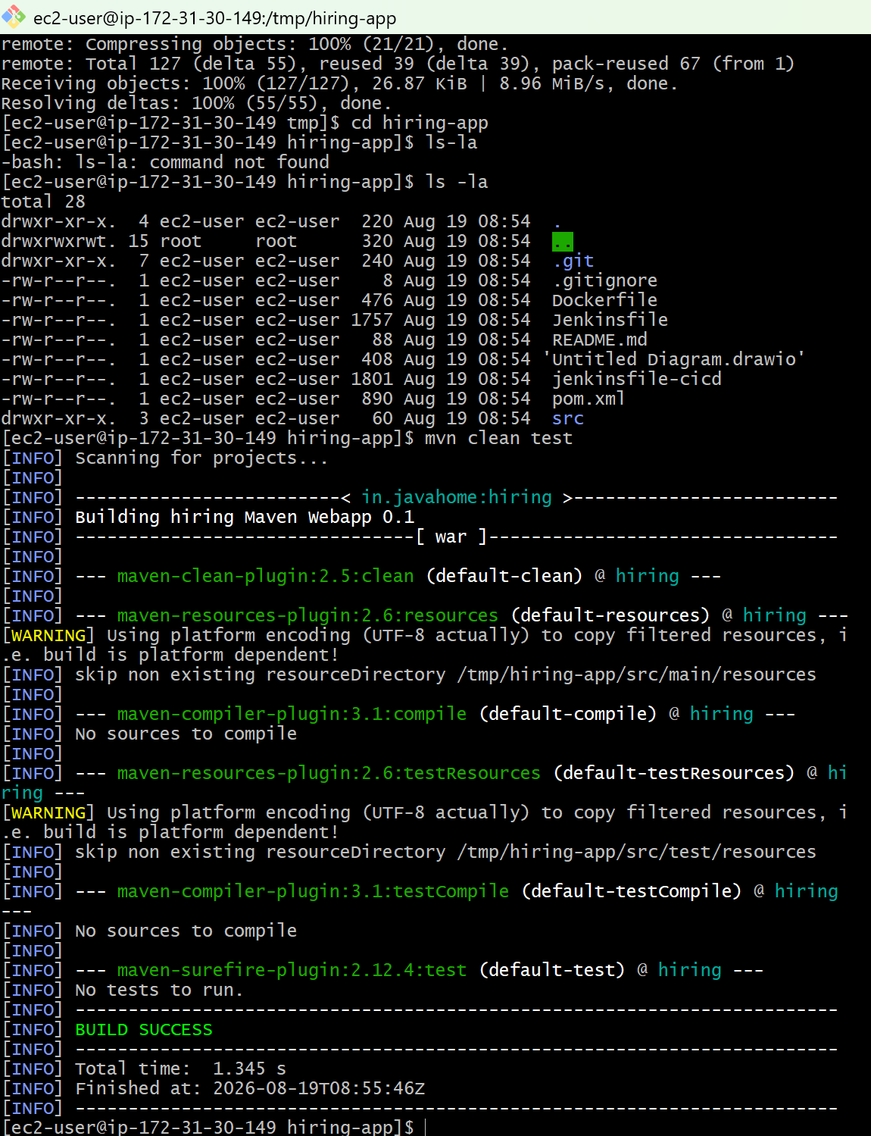

1. Declarative Pipeline
Create:
Jenkins → New Item → hiring-app-declarative → Pipeline → Pipeline script
Stages:
Checkout → Build → Test → Package
pipeline {
agent any

stages {

stage('Checkout') {
steps {
git branch: 'main',
url: 'https://github.com/betawins/hiring-app.git'
}
}

stage('Build') {
steps {
sh 'mvn clean compile'
}
}

stage('Test') {
steps {
sh 'mvn test'
}
}

stage('Package') {
steps {
sh 'mvn package -DskipTests'
}
}
}
}

Flow
Checkout
↓
Build
↓
Test
↓
Package
This is the Declarative Pipeline because it uses:
pipeline {
agent any
stages {
stage('...') {
steps {
...
}
}
}
}
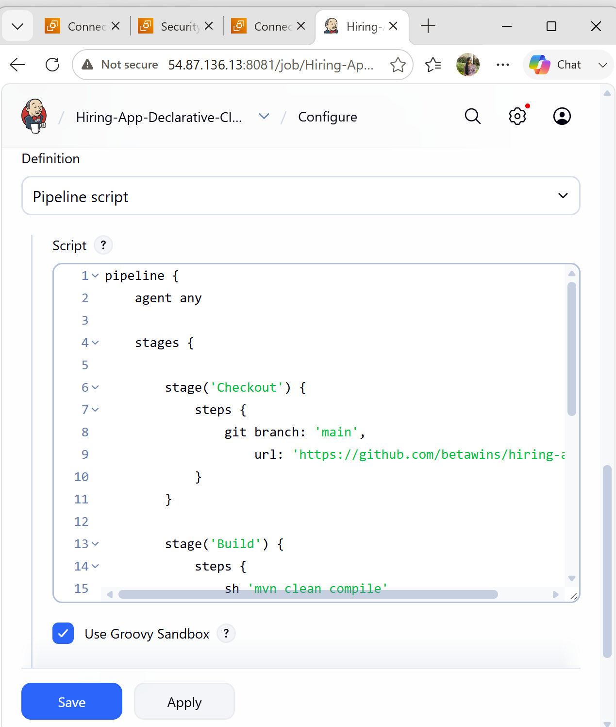
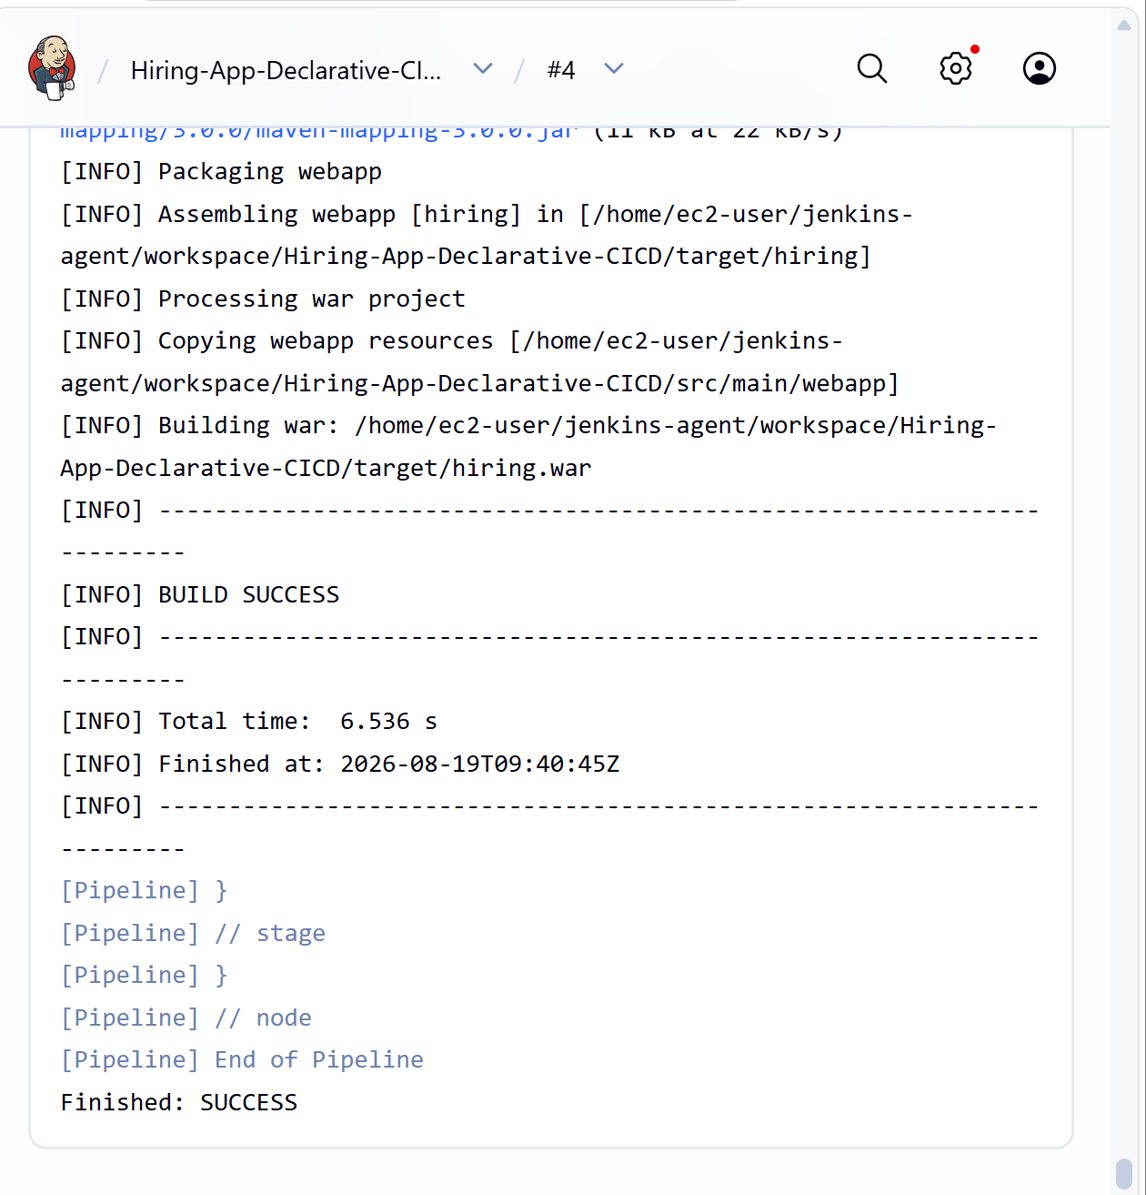
Create one Scripted pipeline job
2. Scripted Pipeline
Create:
Jenkins → New Item → hiring-app-scripted → Pipeline → Pipeline script
The Scripted Pipeline uses node and does not have the same fixed pipeline { stages { } } structure.
node {

stage('Checkout') {
git branch: 'main',
url: 'https://github.com/betawins/hiring-app.git'
}

stage('Build') {
sh 'mvn clean compile'
}

stage('Test') {
sh 'mvn test'
}

stage('Package') {
sh 'mvn package -DskipTests'
}
}
Flow
node
│
├── Checkout
│
├── Build
│
├── Test
│
└── Package
Main difference
Declarative:
pipeline {
agent any

stages {
stage('Build') {
steps {
sh 'mvn clean compile'
}
}
}
}

Scripted:
node {
stage('Build') {
sh 'mvn clean compile'
}
}

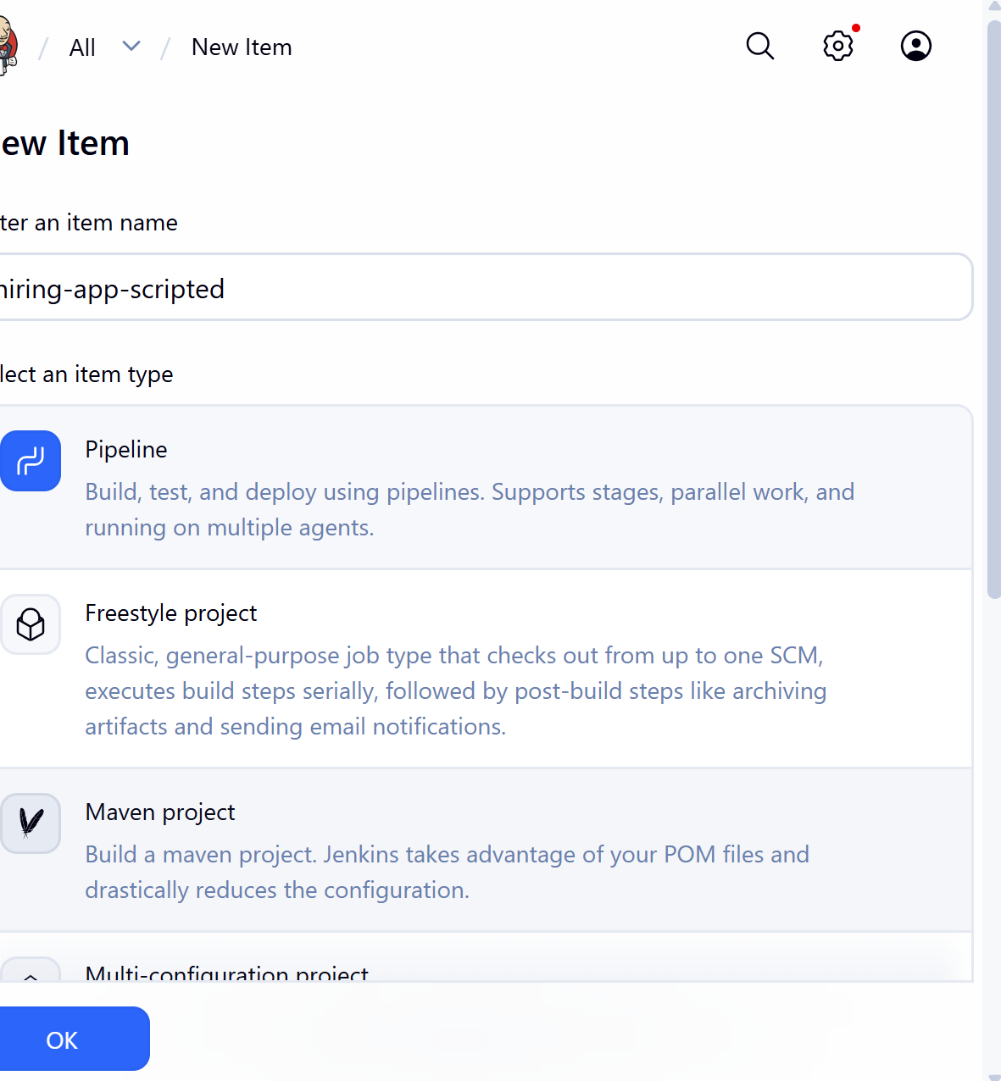
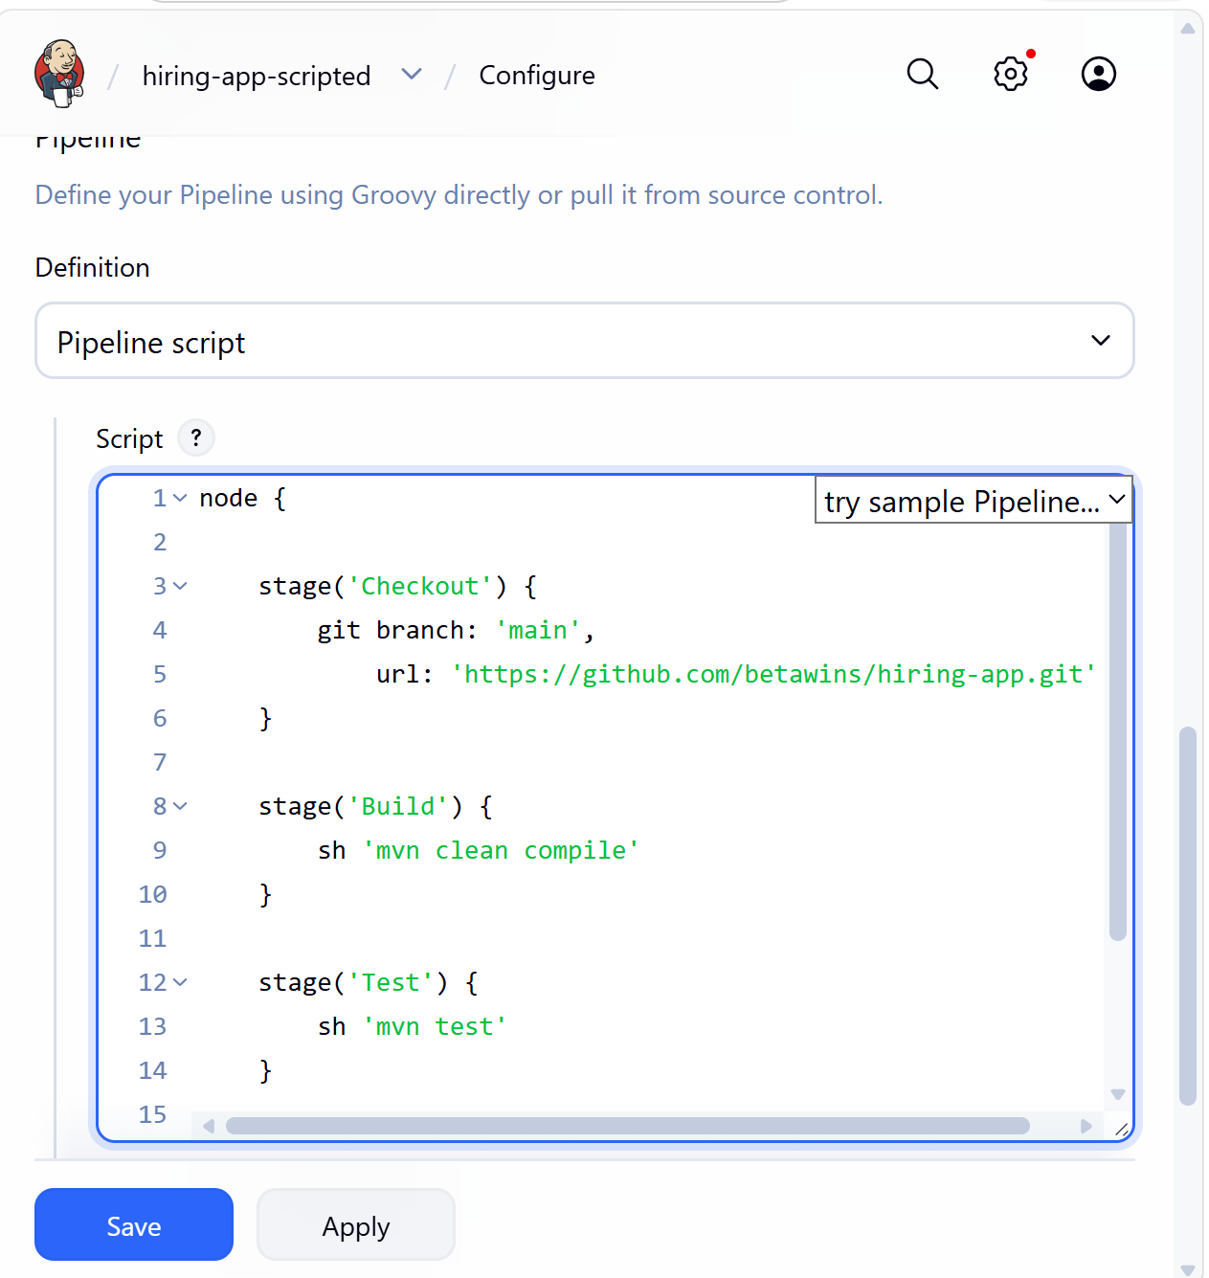
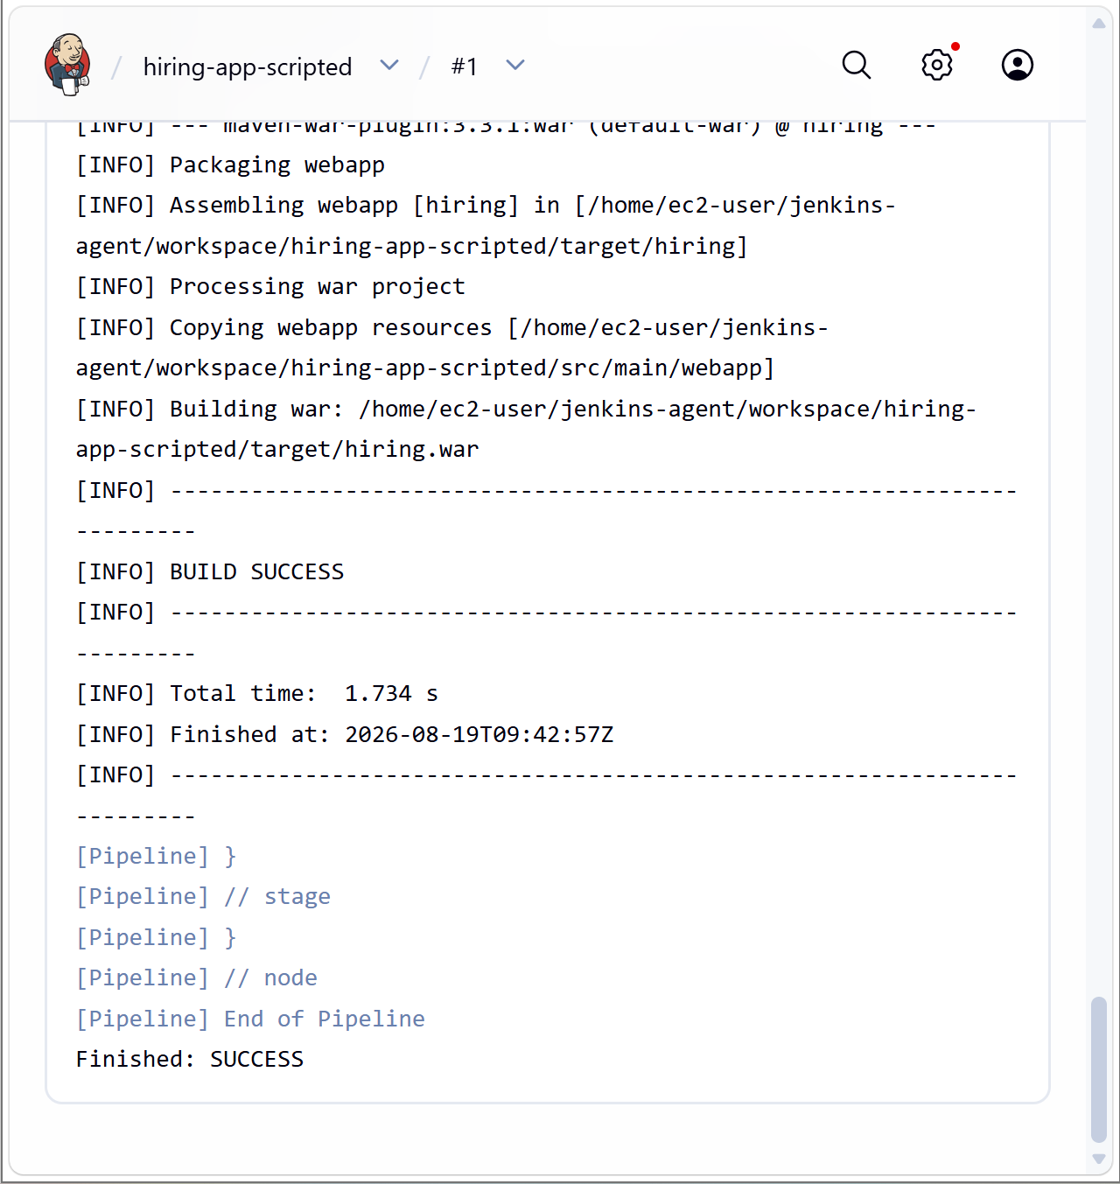

3. Multi-Stage Pipeline
For your assignment, you can make the stages more detailed.
Create:
Jenkins → New Item → hiring-app-multistage → Pipeline
pipeline {
agent any

stages {

stage('Checkout') {
steps {
echo 'Checking out source code...'

git branch: 'main',
url: 'https://github.com/betawins/hiring-app.git'
}
}

stage('Compile') {
steps {
echo 'Compiling application...'

sh 'mvn clean compile'
}
}

stage('Unit Test') {
steps {
echo 'Running unit tests...'

sh 'mvn test'
}
}

stage('Package') {
steps {
echo 'Creating WAR package...'

sh 'mvn package -DskipTests'
}
}

stage('Verify Artifact') {
steps {
echo 'Checking generated WAR file...'

sh 'ls -lh target/'
}
}
}
}
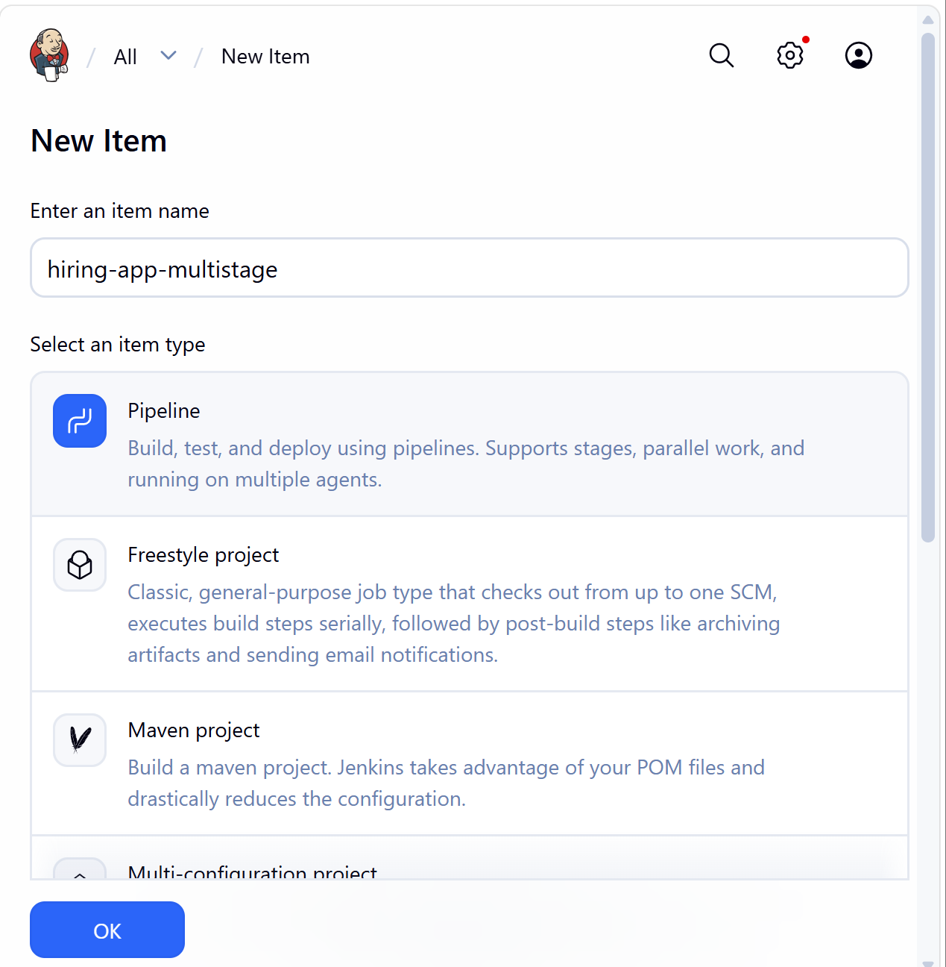

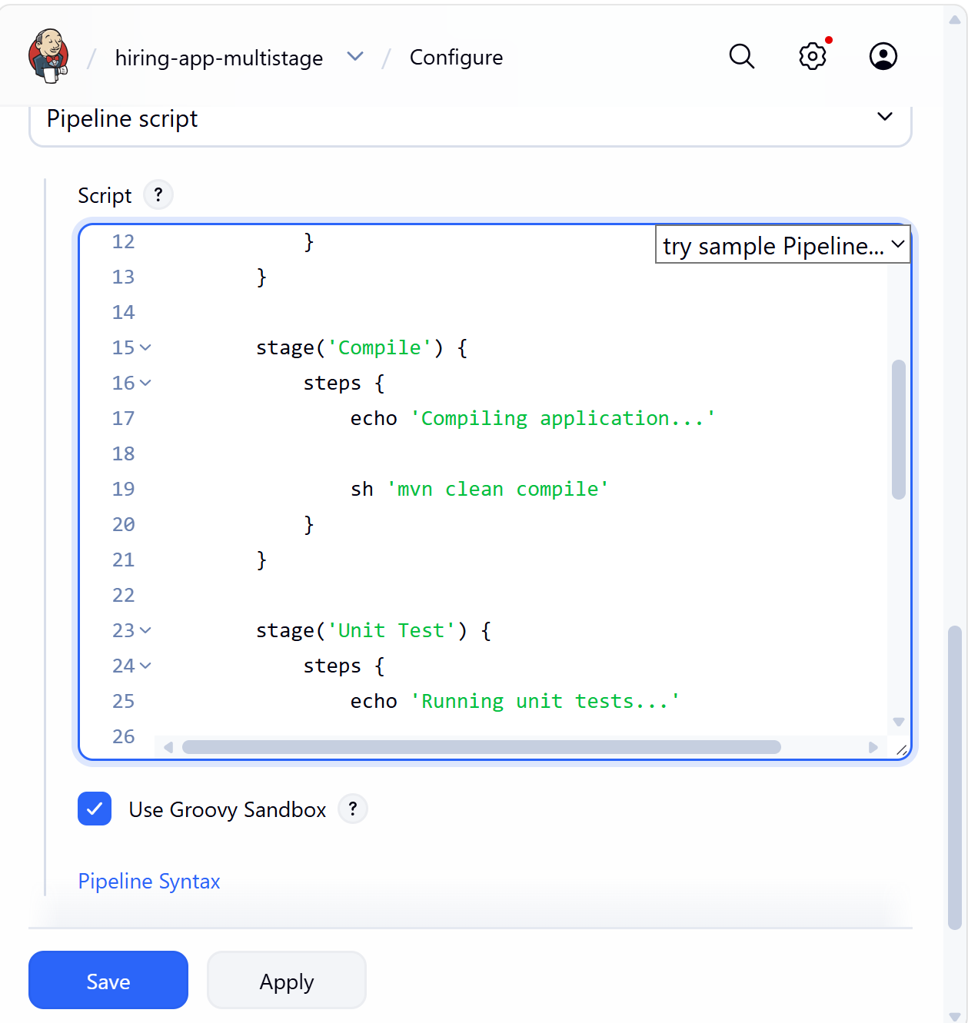
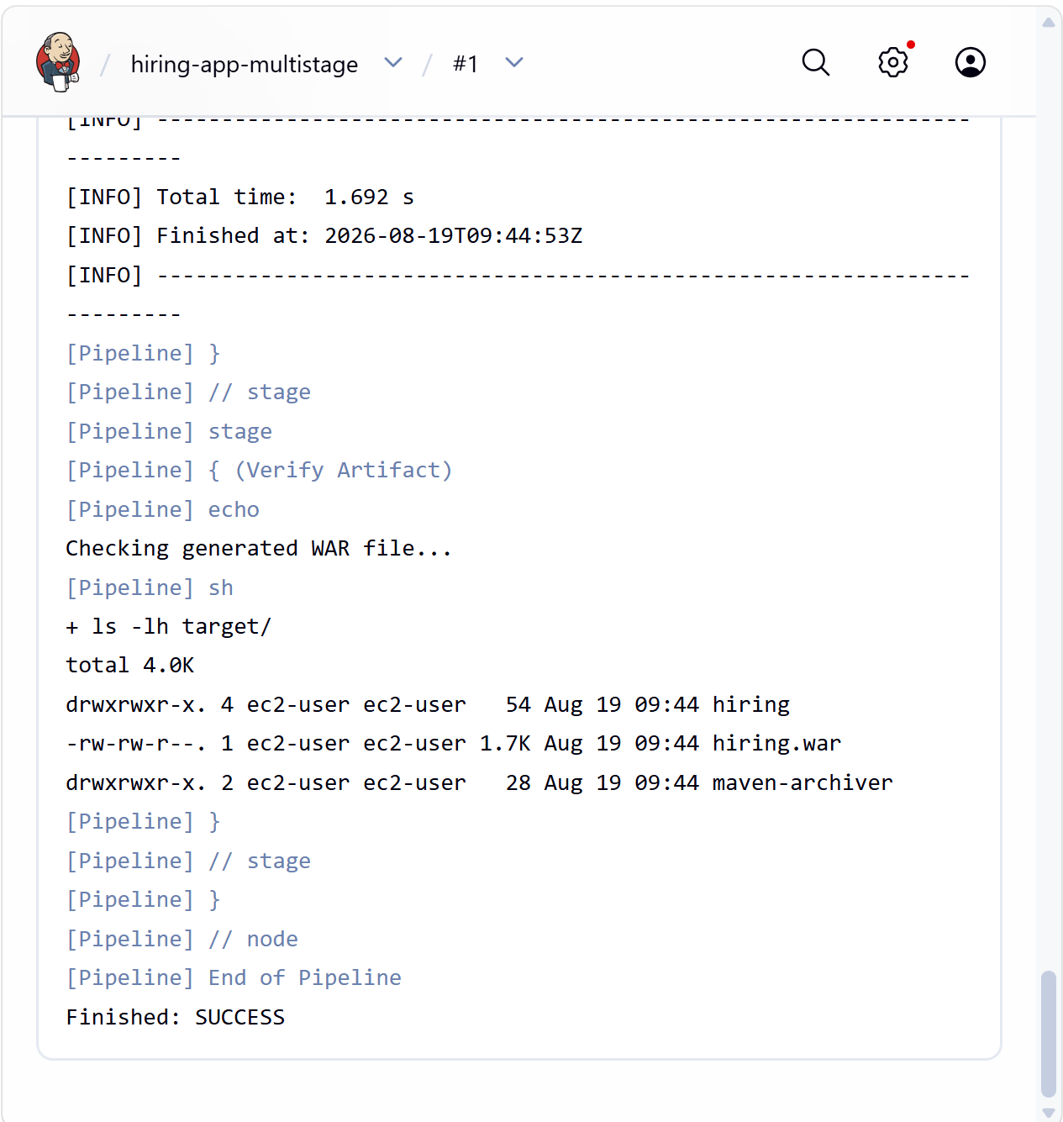

4. Parallel Stage Pipeline
This one is especially useful for your assignment because some activities can run at the same time.
For example, after checkout, we can run:
Checkout
↓
┌──────┴──────┐
↓ ↓
Test Code Check
↓ ↓
└──────┬──────┘
↓
Package
Create:
Jenkins → New Item → hiring-app-parallel → Pipeline
pipeline {
agent any

stages {

stage('Checkout') {
steps {
git branch: 'main',
url: 'https://github.com/betawins/hiring-app.git'
}
}

stage('Parallel Checks') {
parallel {

stage('Unit Test') {
steps {
echo 'Running unit tests...'

sh 'mvn test'
}
}

stage('Compile Check') {
steps {
echo 'Running compile check...'

sh 'mvn clean compile'
}
}
}
}

stage('Package') {
steps {
echo 'Creating WAR package...'

sh 'mvn package -DskipTests'
}
}
}
}
Flow
Checkout
│
↓
┌───────────────┐
│ Parallel │
│ │
│ ┌─────────┐ │
│ │ Test │ │
│ └─────────┘ │
│ + │
│ ┌─────────┐ │
│ │ Compile │ │
│ └─────────┘ │
└───────┬───────┘
↓
Package

The important part is:
stage('Parallel Checks') {
parallel {
stage('Unit Test') {
steps {
sh 'mvn test'
}
}

stage('Compile Check') {
steps {
sh 'mvn clean compile'
}
}
}
}

Jenkins executes Unit Test and Compile Check concurrently.
